FT/GN/61A/00/02.07.18
 | Faculty Department: CSE Academic Year: 2025-2026 | Submission Date: 20.03.2026  Max. Marks: 50
B.E: CS Specialisation: NA
Student Department: CSE Semester: IV Assignment No: II
Sub. Code & Name : CS22403 & Design and Analysis of Algorithms

Q. No. | Question / Task / Activity | CO* | RBT  Level# | Marks
1 | Give the recurrence equation for the following problems using Dynamic Programming:  - Knapsack Problem  - Longest Common Subsequence  - Optimal BST  - Warshall’s and Floyd’s Algorithm | 2 | U | 10
2 | Experiential Learning:  Use the Algorithm Visualizer to simulate the Longest Common Subsequence (LCS) algorithm. Enter the strings ABCBDAB and BDCABA as inputs and run the visualization. Observe how the dynamic programming table is filled step by step during the execution. Identify the final Longest Common Subsequence and its length from the simulation. Take screenshots of the all stages of the DP table. | 3 | AP | 10
3 | Consider the following weighted graph with vertices V={A,B,C,D,E}and non-negative edge weights.  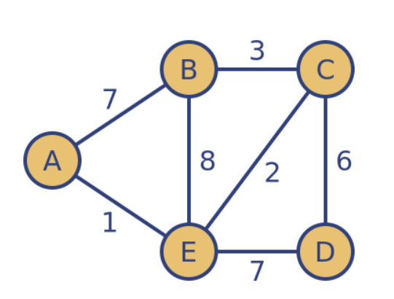  - Write the algorithm for Dijkstra’s algorithm to find the shortest path from a source vertex to all other vertices in a weighted graph.  - Apply the algorithm to find the shortest path from source vertex A to all other vertices in the given graph.  - Show the step-by-step construction of the distance table during each iteration.  - Determine the final shortest path and minimum distance from the source vertex to every other vertex.  - Provide the time complexity analysis of the algorithm.  Note: Clearly show the intermediate distance values at each iteration. | 3 | AN | 15
4 | Consider the text string T = “LIKESOVERLIKES” and the pattern P = “LIKE”.  - Write the algorithm for the Rabin–Karp algorithm used in string pattern matching.  - Apply the algorithm to find all occurrences of the pattern PPP in the given text TTT.  - Show the rolling hash computation for the pattern and each substring of the text at every shift.  - Identify the starting indices where the pattern occurs in the text.  - Provide the time complexity analysis of the algorithm and explain the best, average, and worst cases.  Note: Clearly show the intermediate hash values calculated at each step. | 3 | AN | 15
Total |  |  |  | 50

